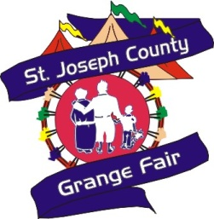
St Joseph Co Grange Fair
PO Box 578 Centreville MI 49032
269-467-8935
www.centrevillefair.com
Celebrating our Family Fair since 1851

To: Area Businesses

We have many businesses in the county that have expressed an interest in being a part of the Fair. Since we have a limited number of sponsorships available, we want to provide those businesses with the opportunity. The money generated from the Friends of the Fair program will be used to provide quality displays and programs during fair week that are available to the public at no charge. These programs may include educational programs, magic shows, exotic animal exhibits or petting zoos.

The Grand Champion Program is a $500 Sponsorship and would include the following benefits:
- Acknowledgment in fair brochure - 60,000 distributed
- Business card size advertisement in Harness Racing Program
- Acknowledgement on Fair Website
- Ten Day passes or one week pass to the fair

The Reserve Champion Program is a $250 Sponsorship and would include the following:
- Business listing (Name, Address & Phone #) in Harness Racing Program
- Acknowledgement on Fair Website
- Five day passes to the Fair

The Blue Ribbon Program is a $100 Sponsorship and will include the following:
- Business name listed in Harness Racing Program
- Acknowledgement on Fair Website
- Two Day passes to the Fair

All sponsors will have their name listed on a banner next to the program being sponsored throughout the fair week and seen by an average attendance of 150,000.

In addition to this program, the Fair has a wide variety of other sponsorship opportunities. For information on these, or with any other questions, please feel free to call the fair office at 269-467-8935

Thank you for your support.

